**Biology: 1. Living Things**

***Please remember to photocopy 4 pages onto one sheet by going A3→A4 and using back to back on the photocopier***

**Syllabus**

**OB38** Understand how to use a simple key to identify plants and animals, including vertebrates and invertebrates

**OB39** Investigate the variety of living things by direct observation of animals and plants in their environment; classify living organisms as plants or animals, and animals as vertebrates or invertebrates

**OB40** Identify the basic life processes and characteristics common to all living organisms: nutrition, respiration, excretion, growth, reproduction, movement and response

**OB41** Recall that living things are composed of cells, tissues, organs and systems, and understand that growth results from cell division

**Student Notes**

**Biology is the study of living things (called organisms)**

The living things which we are most familiar with are plants and animals.

|  |  |
| --- | --- |
| **Plants** | **Animals** |
| Make their own food | Do not make their own food |
| Do not move from place to place | Move from place to place |
| Have cell walls | Do not have cell walls |

Animals can then be sorted into two groups:

1. ***Vertebrates*** = Animals that have a backbone. (Mammal, fish, bird, reptile, amphibian).
2. ***Invertebrates*** = Animals that do not have a backbone. (Spiders, worms, jellyfish, anemones, etc).

**Biology Keys**

A key in Biology is a set of instructions which help us to identify or classify an organism.

The key on the right helps us to identify classify different types of vertebrates.

Can you identify where humans fit into this map?

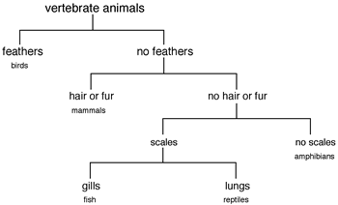

**Example 2: Identify the animals below using the key on the next page**

1.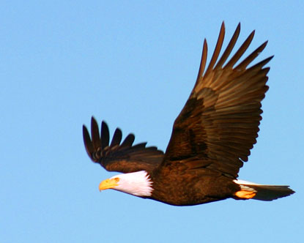 _______________5.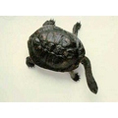_____________

2.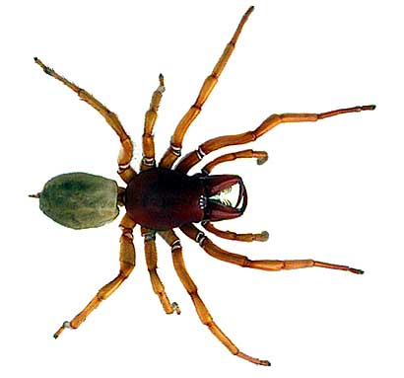 ______________ 6. 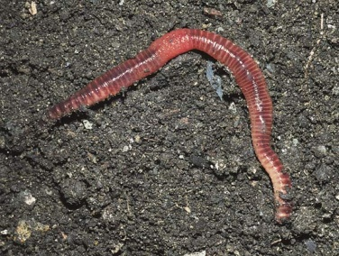 _____________

3.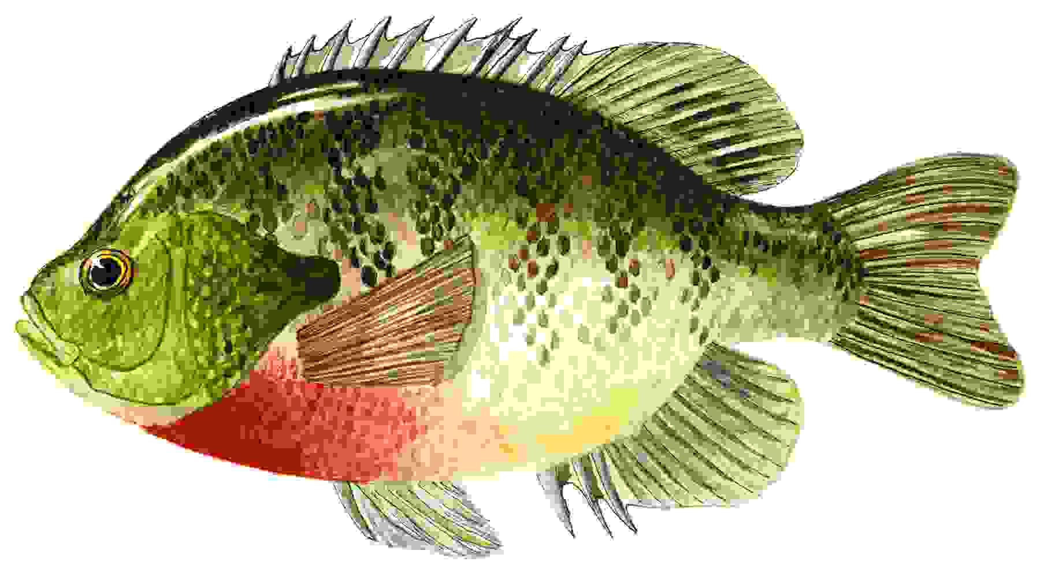_____________ 7. 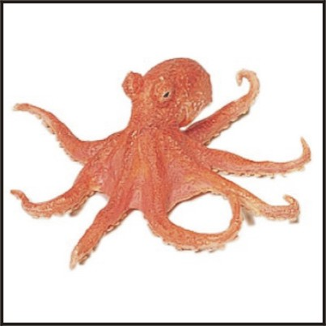 _______________

4.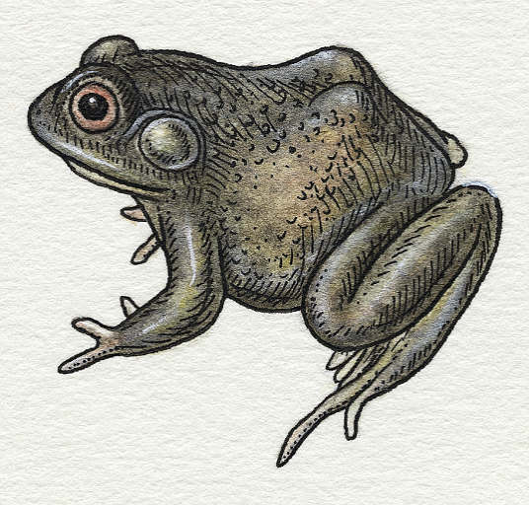 ____________ 8. 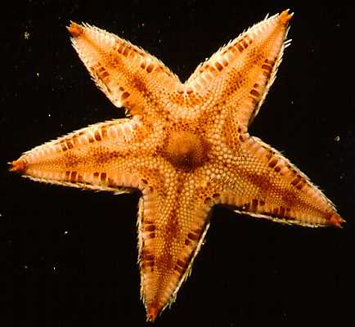 _______________

.

9.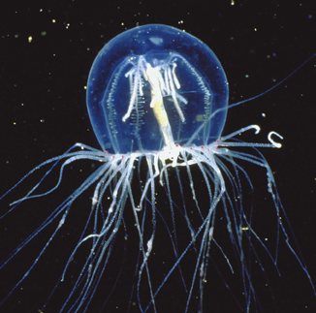 ________________

Does it have a backbone?

Vertebrate

Invertebrate

Y

N

Does it have wings?

Y

N

BIRD

Does it have legs?

Does it have a shell?

Arthropods

Y

N

Y

Y

Y

Mammals

Y

N

Does it have segmented body?

N

Coelenterate (e.g. jellyfish)

Does it have spiny skin?

Does it have a jelly like body?

N

Lots

Centipede

Millipede

6

Insects

8

Spiders

How many legs has it got?

Does it have fur?

N

Y

Y

Reptiles

Does it have scaly skin?

N

N

Does it live in the water some of the time?

FISH

Y

Does it live in the water all the time?

**Basic life processes and characteristics common to all living organisms**  
All living things have 7 life processes or characteristics in common.   
These are **(**think **‘Mrs Gren’)**:

Y

Amphibian  
(e.g. frog, turtle)

Annelids  
(e.g. earthworms)

Mollusc  
(e.g snails)

Echinoderm  
(e.g. starfish, octopus)

1. **Movement**   
   All living things can move. Animals can walk, fly etc, plants move their parts.
2. **Respiration**   
   Respiration is the release of energy from food. Aerobic respiration uses oxygen to obtain energy from food.
3. **Sensitivity**  
   Sensitivity is the ability to detect and respond to stimuli or changes in the environment.
4. **Growth**  
   All living things can grow/increase in size.   
   This happens through cell division where cells have the ability to make copies of themselves.
5. **Reproduction**  
   Reproduction is the formation of new individuals.   
   Organisms must be able to reproduce themselves or their species will become extinct.
6. **Excretion**   
   Excretion is getting rid of waste products from chemical reactions in the body e.g. carbon dioxide.
7. **Nutrition**   
   Nutrition is the way organisms obtain and use food. Food is needed as a source of materials and energy.

When you think about it, there is one other characteristic which is common to all living things: death. But it seems that like nobody ever wants to talk about this; maybe people think that if we don’t talk about it, it won’t happen.

Which of the following is alive?

* a virus
* a fire
* a sperm cell
* a frozen embryo (an embryo frozen for almost 20 years has recently resulted in a healthy birth using IVF)

**Cells, Tissues, Organs and Systems**

**All organisms are composed of cells which form tissues which form organs which in turn form systems.**

**Cells → Tissues → Organs → Systems**

**Cells**

Cells are the main building blocks of life, e.g. blood cells and skin cells.

(We will look at them in detail in the next chapter).

**Tissues**

A tissue is made up of a group of similar cells which carry out the same function, e.g. heart tissue, bone tissue and muscle tissue.

**Organs**

An organ is made up of different types of tissue working together, e.g. the heart and the lung.

**Systems**

A system is formed by a group of organs working together, e.g. the reproductive system and the digestive system.

**Question: Is skin an organ or a tissue?**

The skin is classified as an organ because there are different types of cells which work together to function as a whole. The skin has several types of cells, including cells to make the skin, cells to make hair and cells that secrete sweat.**The bits they don’t want you to know about**

**“It’s extraordinary that so much time is spent educating people about birth and sex, but so little about this equally profound thing [death] that happens to everyone.**

Paul Murray (Irish Hospice Foundation)

When discussing ‘Living Things’, why are so few people prepared to discuss ‘Death’?  
Is death natural or unnatural?  
How do most animals in ‘nature’ die?  
If another animal attacked a koala bear or a bunny rabbit who would you like to see win the fight? Why?  
Every single one of us will die someday - have you ever discussed your death with anyone?  
Has anyone else ever discussed their death with you?

Nearly 30,000 people die every year in Ireland. Should we spend a little more time talking about this?

Imagine you’re eighty years old. You are sick and have the option of living for another year if you remain in hospital or living for six months more if you live at home. Which would you choose and why?

**For you to investigate:**

Have you seen the film ‘The Bucket-List’?

Have you a list of things you would like to do before you die?  
Have you written them down – what are they (how many are secret)?

How many people die as a result of road accidents in Ireland every year?

How many people die by suicide every year?

**Exam Questions**

1. [2012 OL]

All living organisms have common characteristics e.g. respiration.

Give two other characteristics of living organisms.

1. [2011][2009 OL][2007 OL][2012 OL]

Name one invertebrate animal and one vertebrate animal

1. [2009 OL]

|  |
| --- |
| 36 – 370 C  86 – 870 C |

1. Choose the correct temperature range of human body temperature from the list on the right.
2. Give one reason for a change in body temperature.
3. [2008 OL]

|  |  |
| --- | --- |
| Letter | Key feature of organism |
| A | Four pairs of legs |
| B | Segmented body, no legs |
| C | Three pairs of legs |
| D | Eight to ten pairs of legs |

The table shows a simple key used to identify some common organisms found in a habitat.

In the case of any two of the organisms shown on the right, write the letter corresponding to a key feature given in the table above beside the organism which that best describes.

1. [2008 OL]

|  |  |
| --- | --- |
|  | Muscle |
|  | Digestive system |
|  | Heart |

1. Write the letter T opposite the name of a body tissue in the table on the right.
2. Write the letter O beside the name of a body organ in the table on the right.

**Exam Solutions**

1. Nutrition (feeding)// excretion// reproduction// growth// movement//response (sensitivity)
2. Invertebrate: slug/ snail/ mussel/ bee/ wasp/ fly/ spider/ starfish/ prawn…

Vertebrate: fish/ lizard/ snake/ dog/ cat/ bird/ frog/ newt/ toad/ bat/ whale…

1. 36 – 370 C
2. Illness / stress / pain / exercise
3. A: Spider
4. C: Wasp
5. D: Caterpillar
6. T: Muscle
7. O: Heart

**Other Test Questions**

1. List six characteristics of living things.
2. What is an organ made up of?
3. Define (i) sensitivity, (ii) reproduction, (iii) respiration and (iv) excretion.
4. Explain the term tissue.
5. What process do cells undergo to allow growth in organisms?